Selectboard Office
P.O. Box 317
Concord, VT 05824
(802)695-2910, ext.21
(802)284-2009, Fax

Bill Humphrey-Chairman
Chris Fournier-Vice-Chairman
George Morehouse
Shannon Chapman
Denis LaMadeleine

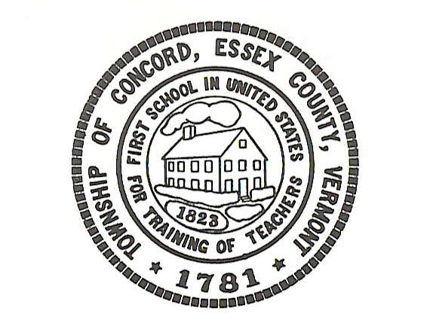

Concord Selectboard Regular Meeting Agenda
Tuesday, October 4, 2022 @ 6:00pm
Municipal Building and Zoom

Join Zoom Meeting
https://zoom.us/j/2288877241 Meeting ID: 228 887 7241 By Phone 1-646-558-8656

Call to Order

Approval of Agenda

Approval of the September 6, 2022 Regular Meeting Minutes

Citizen’s Concerns---5 Minutes Limit
- Dylan Ainsworth-Oregon Rd

Old Business
Town Clerk

Town Treasurer

Zoning Administrator

Road Commissioner
- Aubin Electric-$470.00 increase on quote

Fire Department

Planning/Zoning Board
- Community Visit/ARPA Fund Suggestions

Grant Administrator

New Business

Town Hall Report

Danielle Balch
- 5K Run

NEK Broadband Governing Board

Budget Meeting Date?

E-Z Trash Contract Renewal

Summary of September 15th conversation with Global
- Executive Session Item

Ordinance Violations
- Steigleman Property-Update
- Austin Property-No Update
- Hambly Property-Update From Bill H.

Other

Executive Session: If discussion warrants, and the Board so votes, some items may be held in Executive Session.

Adjournment

Posted: October 29, 2022

