Selectboard Office
P.O. Box 317
Concord, VT 05824
(802)695-2910, ext.21
(802)284-2009

Bill Humphrey-Chairman
Chris Fournier-Vice-Chairman
George Morehouse
Shannon Chapman
Denis LaMadeleine

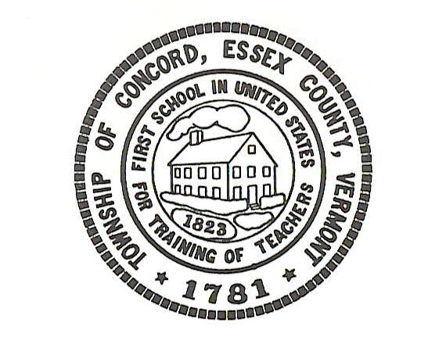

Concord Selectboard Special Budget Meeting Agenda
Tuesday, November 29, 2022 @ 6:00pm
Municipal Building

Call to Order

Approval of Agenda

Budget Work Session

Executive Session: If discussion warrants, and the Board so votes, some items may be held in Executive Session.

Recess or Adjourn

Posted: November 22, 2022

