Selectboard Office
P.O. Box 317
Concord, VT 05824
(802)695-2910, ext.21
(802)284-2009, Fax

Bill Humphrey-Chairman
Chris Fournier-Vice Chairman
George Morehouse
Shannon Chapman
Denis LaMadeleine

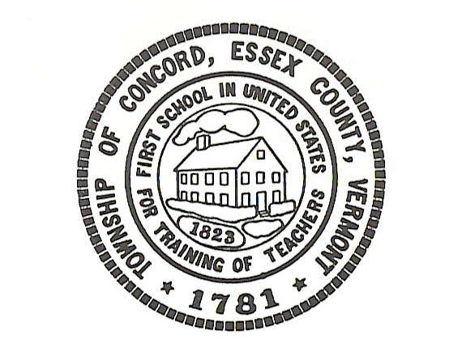

Concord Selectboard Special Meeting Agenda
Tuesday, November 29, 2022 – 5:45pm to 6:00pm
Municipal Building

Call to Order

Approval of Agenda

Special Items
FY23 Municipal Resolution for Municipal Plan Grant

Other

Executive Session: If discussion warrants, and the Board so votes, some items may be held in Executive Session.

Adjournment

Posted: November 22, 2022

