Selectboard Office
P.O. Box 317
Concord, VT 05824
(802)695-2910, ext.21
(802)284-2009, Fax

Bill Humphrey-Chairman
Chris Fournier-Vice-Chairman
George Morehouse
Shannon Chapman
Denis LaMadeleine

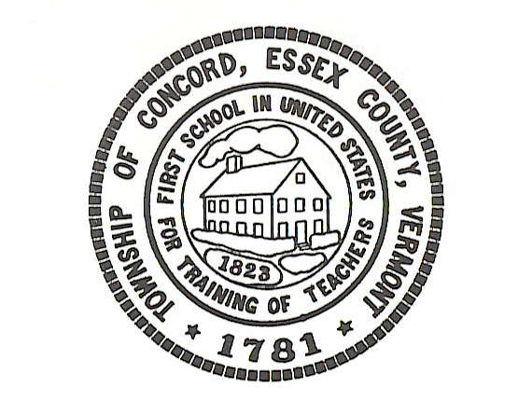

Concord Selectboard Regular Meeting Agenda
Tuesday, December 6, 2022 @ 6:00pm
Municipal Building

Call to Order

Approval of Agenda

Approval of the November 01, 2022 Regular Meeting Minutes and November 29, 2022 Special Meeting Minutes

Citizen’s Concerns---5 Minutes Limit

Old Business

Jon Lillie-Johnson Road

Town Clerk

Town Treasurer

Zoning Administrator

Road Commissioner
- Bradley Vale Update

Fire Department

Planning/Zoning Board

Grant Administrator

New Business

Employee Gift Cards

Tax Map Maintenance Contract Renewal

Noise Ordinance Templates

Ordinance Violations
- Steigleman Property-Update
- Kenneth Copp Property-Update

Other

Executive Session: If discussion warrants, and the Board so votes, some items may be held in Executive Session.

Adjournment

Posted: December 1, 2022

