Selectboard Office
P.O. Box 317
Concord, VT 05824
(802)695-2910, ext.21
(802)284-2009

Bill Humphrey-Chairman
Chris Fournier-Vice-Chairman
George Morehouse
Shannon Chapman
Denis LaMadeleine

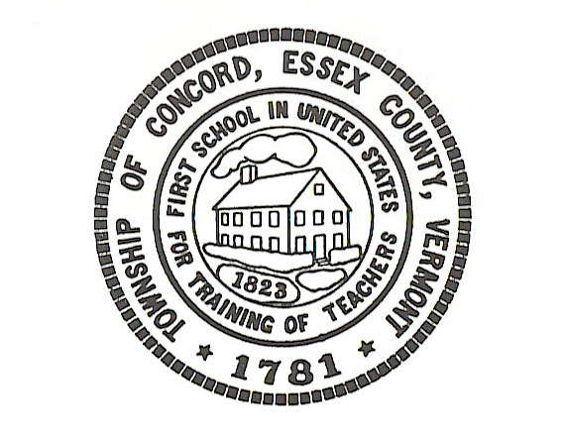

Concord Selectboard Special Meeting Agenda
Site Visit
Tuesday, May 16, 2023 @ 3:30pm
Town Garage

Call to Order

Approval of Agenda

Bradley Vale Road Site Visit

Executive Session: If discussion warrants, and the Board so votes, some items may be held in Executive Session.

Adjourn

Posted: May 18, 2023

