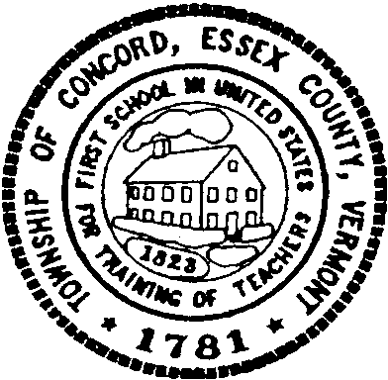

Concord Cemetery Committee Meeting

Tuesday April 1, 2025

5 p.m.

Concord Municipal Building

Meeting Agenda

Call to Order

Approval of Agenda

Approval of Minutes (November 7, 2024)

Sexton Update/Information Session

Other Business

Adjournment