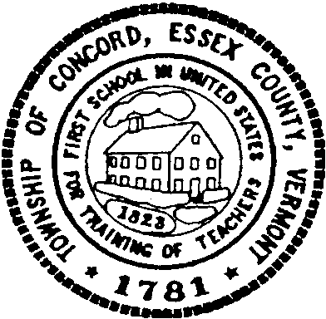

Concord Cemetery Committee Meeting

Tuesday April 1, 2025

5:00 p.m.

Concord Municipal Building

Meeting Minutes

Members Present Sexton Members of the Public

William Humphrey William Gilding Linda Blakslee, Town Clerk

Christopher Fournier

Danielle Balch

Audra Girouard

Call to Order

The meeting was called to order at 5 p.m. by William Humphrey

Approval of Agenda

Chris Fournier made a motion to approve the agenda, with the addition of the item “Board Reorganization”, Danielle Balch seconded. Motion carried 4-0-0.

Board Reorganization

Danielle Balch made a motion to nominate Bill Humphrey as chair, Audra Girouard seconded. Motion carried 3-0-1. Bill Humphrey abstained.

Danielle Balch made a motion to nominate Chris Fournier as Vice-Chair, Audra Girouard seconded. Motion carried 4-0-0

Approval of Minutes

Chris Fournier made a motion to approve the minutes of the November 7, 2024 meeting, Danielle Balch seconded. The motion carried 4-0-0.

Sexton Update/Informational Session

Sexton Bill Gilding updated the board on information he has researched on committee responsibilities and duties. He presented information from All Funeral Services out of NYC. The company is in the business of mapping and maintaining map records for cemeteries. The information will go to the Select Board to ask for funding.

Other Business

None

Adjournment

The meeting was adjourned at 5:45 p.m.