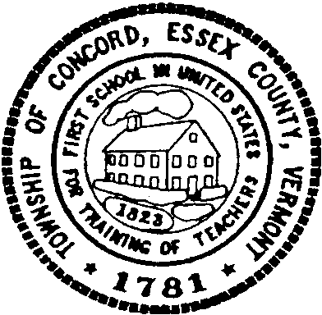

Concord Cemetery Committee

Special Meeting

Tuesday May 6, 2025

4:45 p.m.

Concord Municipal Building

Meeting Agenda

Call to Order

Approval of Agenda

Approval of Minutes (April 1, 2025)

Sexton Update/Information Session

Other Business

Adjournment