Selectboard Office
P.O. Box 317
Concord, VT 05824
(802)695-2910, ext.21
(802)284-2009, Fax

Chris Fournier-Chairman
Bill Humphrey-Vice-Chairman
George Morehouse
Denis LaMadeleine
Jason Payeur

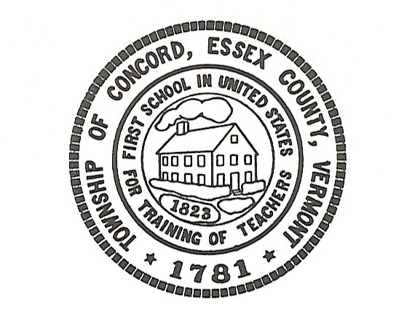

Concord Selectboard Regular Meeting Agenda
Tuesday, October 7, 2025 @ 6:00pm
Municipal Building

Call to Order

Approval of Agenda

Approval of the September 2, 2025 Regular Meeting Minutes

Citizen’s Concerns---5 Minutes Limit

Old Business

Town Clerk

Treasure

Road Commissioner

Assessor

Fire Department

Zoning Administrator

New Business

Heating Oil

Clear Diesel

EZ Trash Contract

Municipal Building Phone System

Town Hall

Cemetery Committee

Other

Executive Session: If discussion warrants, and the Board so votes, some items may be held in Executive Session.

Adjournment Posted: October 2, 2025

Join Zoom Meeting
https://us06web.zoom.us/j/2288877241?pwd=U2ZGVkR1S2Y1NWZKcTZEajNIYVhLUT09&omn=89195927895

Meeting ID: 228 887 7241 Passcode: j3Sv8m

