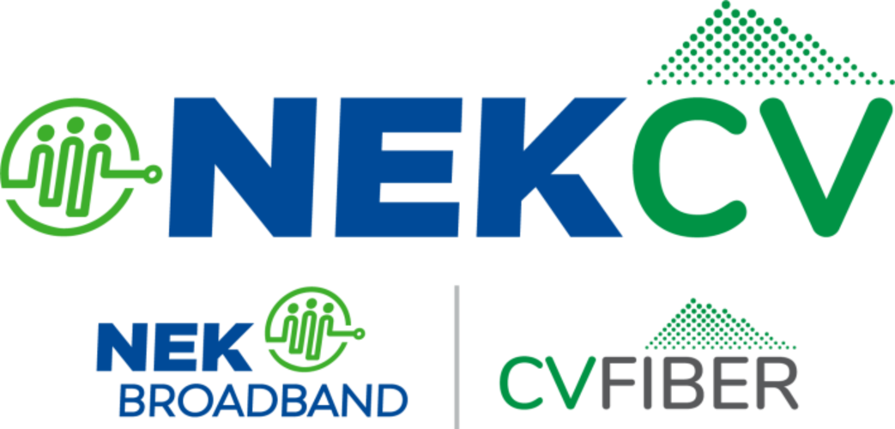
Make a difference in the NEK!
Volunteer Board Member Needed – A Concord Delegate to NEKCV

Concord is seeking a town resident to serve on the Governing Board of NEK Broadband (NEKCV), our regional Communications Union District. NEKCV is a municipal nonprofit, similar to a wastewater or conservation district. We are bringing reliable, high-speed fiber internet to all 72 towns in the NEK and Central Vermont that make up the District, including Concord.
NEKCV has already built over 1,200 miles of fiber, including a significant portion of Concord, and connected more than 2,000 customers. We are on target to reach every location on the electrical grid in our District over the next few years.
This is more than a board seat—it’s an exciting opportunity to help grow and strengthen our local economy, support job creation, and shape how our rural communities evolve. Reliable, affordable fiber internet is essential infrastructure for small businesses, remote workers, farms, students, telehealth, and entrepreneurs. By participating, you’ll help ensure Concord has a voice in building and governing this publicly owned network for long-term community benefit.
The Governing Board meets just four times a year: three 90-minute Zoom meetings and one in-person meeting on the fourth Saturday in October. Board members attend meetings, share information between the town and NEKCV, and help promote the network locally. No telecommunications experience is needed.
If you’re interested in helping shape Concord’s future, and the wider region, please contact the Kitty Ufford-Chase, NEKCV Community Relations Manager, at kitty@nekcv.org or 802-472-1043.

